**1. Elevator Pitch**

[Prompt]

Write an elevator pitch for a new movie reservation website using the following framework:

###

For (Target user group), they want to (pain point).

This (Product Name) is a (product features).

It can (irresistible advantages).

Different from (other competing products), our product (core differentiated competitiveness).

###

The pitch should highlight the common issues faced by moviegoers such as (but are not limited to):

Long, tedious ticket queues.

Difficulty finding companions to watch movies with.

The hassle of buying snacks and drinks.

Lack of interaction during the movie.

Include how the website addresses these challenges by offering:

An online ticket booking system to avoid queues.

A social feature to connect with fellow moviegoers.

A pre-order snack option for convenience.

An interactive app for real-time discussions without disturbing others.

The elevator pitch should emphasize how the service makes the movie reservation experience more enjoyable and convenient by addressing these specific pain points and enhancing the overall experience.

Below after the #EXAMPLE is an example of an Elevator Pitch about the AFS ITA Bootcamp.

#EXAMPLE

For fresh graduates, They want to quickly learn basic DEV skills, build a strong foundation, and adapt to projects. This is AFS ITA Bootcamp,

An in-person, instructor-led course. It can accelerate skill-building through hands-on workshops, real-world practice, and focused feedback. Different from

ThoughtWorks and online courses, Our product offers a 4-week immersive program with a practical focus, ensuring graduates are ready for the job market

2. User Persona

Write an detailed user persona for a new movie reservation website focusing on individual personality and motivation since our website will be more customer-facing (c-end).

When creating the user persona, be mindful of the following points:

- focus more on thinking from the user's perspective

- be more emphathetic when making decisions

- do not presuppose user's positions

- clarify the starting point of the product

For the persona, please include the following details:

- one sentence summary of the persona

- Basic characteristics

- User goal

- Behaviour characteristics

- Pain points and expectations:

Keep in mind the common issues faced by moviegoers (our users) , but are not limited to:

Long ticket queues.

Difficulty finding companions.

Hassle of buying snacks and drinks.

Lack of interaction during movies.

3. User journey  
[Prompt]  
Given the following pain points about movie reservation, and the below user persona, please generate a detailed as-is and to-be user journey which will include the scenario, goal of the user.

For each user’s activity, include the user action、touch points、emotions、pain points、possibility solution.

The activities and concrete behaviours from the users should strictly in chronological order and should be based on the user persona and the pain points provided.

Keep in mind that the user journey will be used to analyze the user pain point and to figure out opportunity in which will be used to brainstorm solutions and design new solution that aiums to help users achieve that goals more smoothly.

For the As-Is user journey, it will be used Used for current state analysis: to understand how business processes operate within the existing system, forming the basis for defining the To-Be Joruney.

For the To-Be user journey, it will focus on addressing the pain points identified in the As-is scenario, it proposes targeted solutions to create a completely new user journey.

For the user journey, please generate it in a table format so it can be easily viewed and understood.

Movie 1:

[Prompt] Generate a movie poster for the movie named "Life of Pie", a knock off of “Life of Pi" where the main character hallucinates the pie is a living being in the middle of the ocean

The person should be realistic and the tone of the poster should be semi-dark, displaying the helplessness of the main character and his mental instability that led to the hallucination

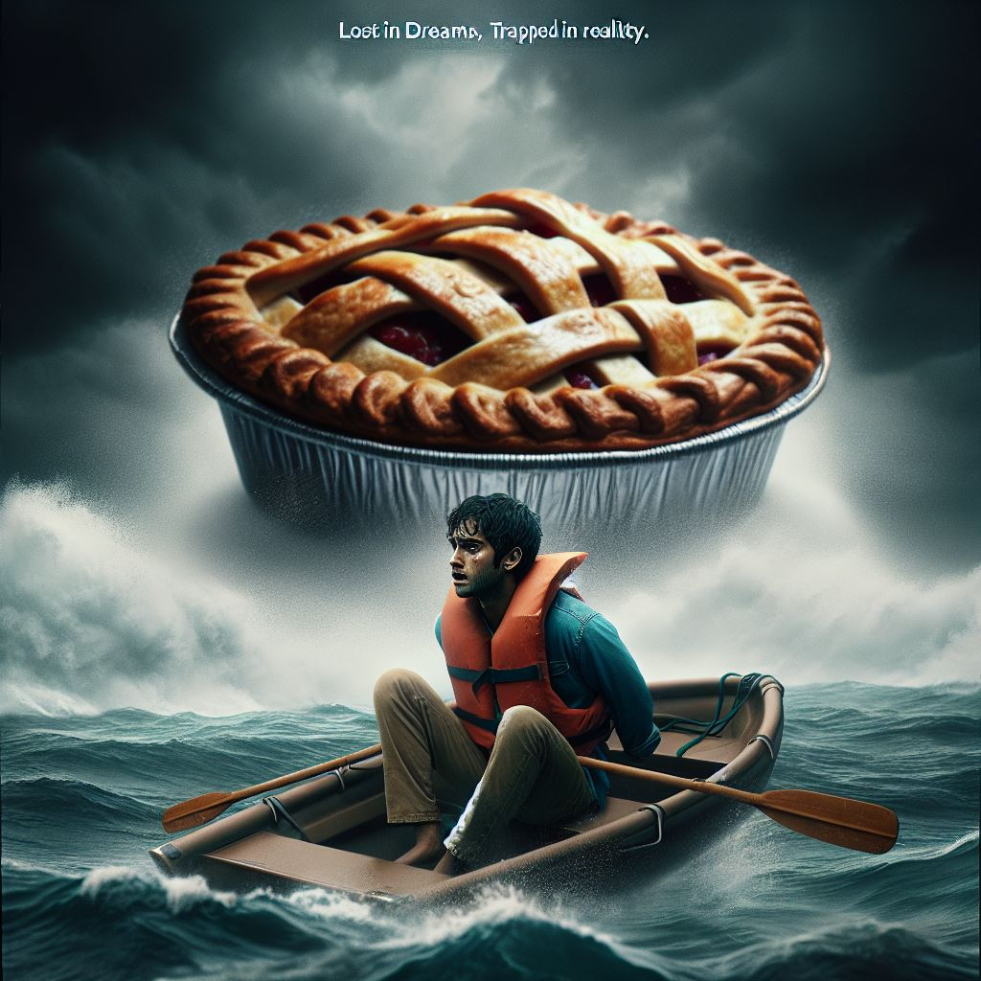

Movie 2：  
[Prompt] Generate a movie poster for the movie named "Spirited Away", based on the popular Japanese animated movie but instead the main character is a old men that so drunk, he is "Spirited", consuming way too much alcohol Keep the cartonish anime style of Studio Ghibli for the poster

Movie 3:

[Prompt] Generate a movie poster for the movie named "Man vs Woman", make it similar in style Godzilla vs Kong where each character is on either side, each with their background color being blue and yellow. The art style should remain funny and charismatic of the old-school American comics.

